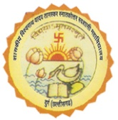 | Department of Mathematics  Govt. V. Y. T. PG. Autonomous College  Durg (C. G.) | 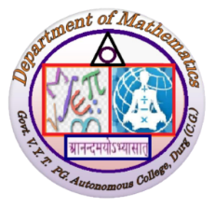
Departmental Activity
2024-25
- 03/11/24
Activity Name | No. of Participants
RMO Examination | 200
- 13/12/24 - Extension lecture on Vedic Mathematics at Dhamdha
- 04/01/25 - Extension Activity by PG Student at Dhamtari
- 04/01/25 - Extension Activity (MMC Workshop) by UG Student at Dhamtari
- 12/01/25
Activity Name | No. of Participants
Madhav Mathematics Competition (MMC-2025) | 24
- 19/01/25
Activity Name | No. of Participants
INMO Examination 2024-2025 | 33
- Guest lecture Series

S. No. | Date | Name Of Resource Person | No. of Student
1 | 08/01/25 | Prof. Rajendra Pawale,  Rt. Prof. Mumbai university | 35
2 | 18/01/25 | Prof. D. Gopal,  GGU Central University Bilaspur | 38
3 | 19/01/25 | Dr. V.K. Pathak,  Govt. B.C.S. PG College Dhamtari | 38
4 | 20/01/25 | Dr. Shashi Thakur,  Govt. C.L.C. College Dhamdha | 38
5 | 20/01/25 | Dr. K.K. Dewangan,  Govt. Digvijay College Rajnandgaon | 40
6 | 23/01/25 | Dr. V.K. Sahu,  Govt. M.L.J. College khursipar Bhilai | 29
7 | 29/01/25 | Dr. Deena Sunil,  Indira Gandhi national tribal university Amarkantak M.P. | 46
8 | 01/02/25 | Prof. B.S. Thakur  HOD, SOS in Mathematics  PRSU Raipur | 45
9 | 08/02/25 | Prof. P. Jha,  Principal, Govt. Naveen College Komakhan | 43
10 | 13/02/25 | Dr. Varsha Karanjgaonkar  Govt. Nagarjuna Science College Raipur | 39
11 | 24/03/25 | Mr. Hitendra Kumar  Indian Institute for Science education and Research (IISER) Pune | 80
12 | 26/03/25 | Mr. Hitendra Kumar  Indian Institute for Science education and Research (IISER) Pune | 24

- 14/02/25 - Study tour (National Institute of Technology, Raipur)
- 12/03/25
Activity Name | No. of Participants
International Women’s Day Celebration | 59
- 24/03/25 to 28/03/25 – Educational tour (Regional Science Centre Bhubaneswar, Odisa)

